Object Oriented Programming

Project Specification:

Weekly To Do List application that can help the users to manage their daily tasks for each day in a week. The application allows the users to add tasks, remove tasks, mark the tasks, and see the tasks on the specific day that the users want to see. The primary function of the application are:

* provide a task management for the users
* Error handling the users input
* implement the object oriented approach using inheritance and interfaces

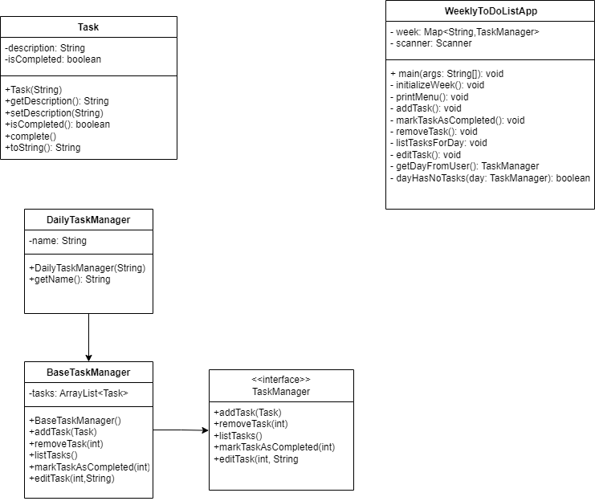

* TaskManager Interface:  
  for managing tasks such as adding, removing, listing, marking as completed, and editing the tasks
* BaseTaskManager Class:
* Implements the TaskManager Interface
* provide a list of tasks and some common functionality to manage the tasks
* DailyTaskManager Class:  
  extending BaseTaskManager class and managing the tasks for a specific day by identifying by the name of the day that the users input
* Task Class:  
  Represents a task with a description and a completion status for the task and also providing methods to get and set the description of the tasks in a day such as check if the task is completed, mark the task, and convert the task into a string representation
* WeeklyToDoListApp Main Class:

as the main class, it manages the app to run and contain a map of days to the respective task managers. It main function is providing a various methods to interact with the users, such as initializing the week, printing the menu of the main program, adding tasks, removing tasks, check the tasks, mark the tasks if it completed, edit the tasks, and getting the day from the users input

The Data Structure:

ArrayList (BaseTaskManager):

The ‘tasks’ attribute is an ‘ArrayList<Task>’, which hold the list of the tasks and be used in some various methods such as ‘addTask(Task task)’, ‘removeTask(int index)’, ‘listTasks()’, ‘markTaskAsCompleted(int Index)’, and ‘editTask(int index, String newDescription)’

HashMap (WeeklyToDoListApp):

The ‘week’ attribute is a ‘Map<String, TaskManager>’, Which maps each day of the week (as a ‘String’) to a corresponding ‘DailyTaskManager’. By using HashMap, it is more efficient to retrieve the task manager for any day in the week.

Solution Scheme:

* Problem Definition:  
  creating a weekly to do list application where the users can:  
  1.Add Tasks for each day of the week

2.Mark Tasks as completed  
3.Remove the task  
4.List Tasks for a specific day  
5.Edit Task.

* Design Using OOP Principles:  
  The design that I use is based on OOP principles, by using interfaces, inheritance, and Polymorphism.

Interface and Classes:  
TaskManager Interface:  
defines the method for managing tasks, such as adding, removing the task, listing, marking as completed, and editing tasks.  
  
BaseTaskManager Class:  
Implements the TaskManager Interface and provides the base functionality for managing a list of tasks. This class will serve as a superclass for specific task managers.  
  
DailyTaskManager Class:  
Extending BaseTaskManager Class to manage the task for a specific day of the week.The function of this class is to add specific daily tasks, such as identifying the day.  
  
Task Class:

Represents an individual task with attributes for description and completion status of the task. this class methods to manipulate and display the task information is marked or not.  
  
WeeklyToDoListApp Class:

the main application to interact with the user and managing the weekly schedule using a HashMap to map days of the week.

Implementation:  
Task Manager Interface:  
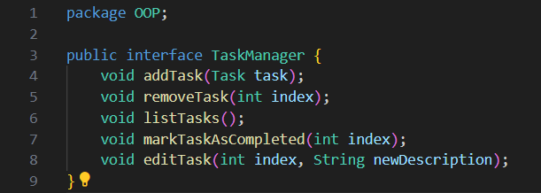

BaseTaskManager Class:  
  
  
  
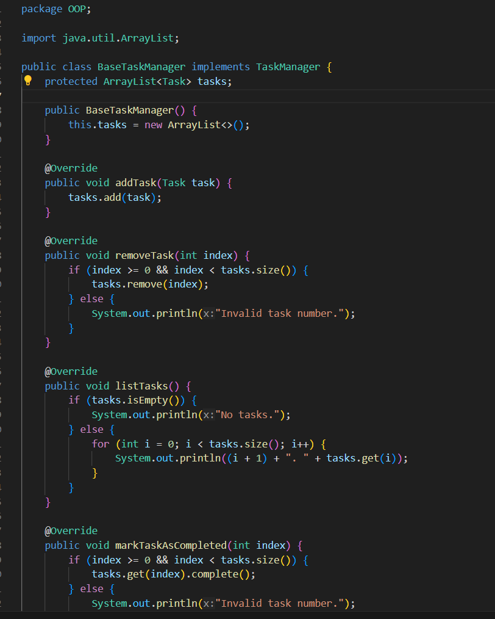  
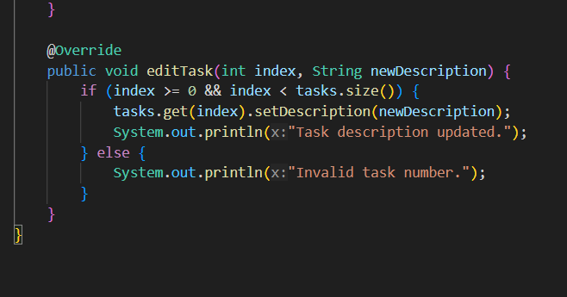\

DailyTaskManager Class:  
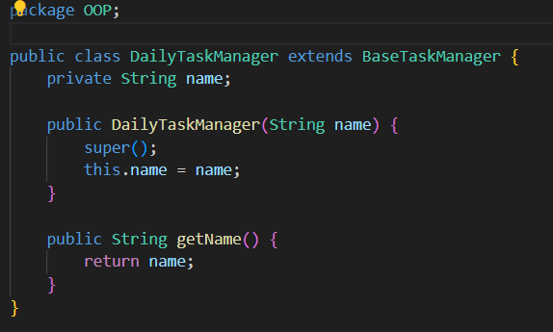

Task Class:  
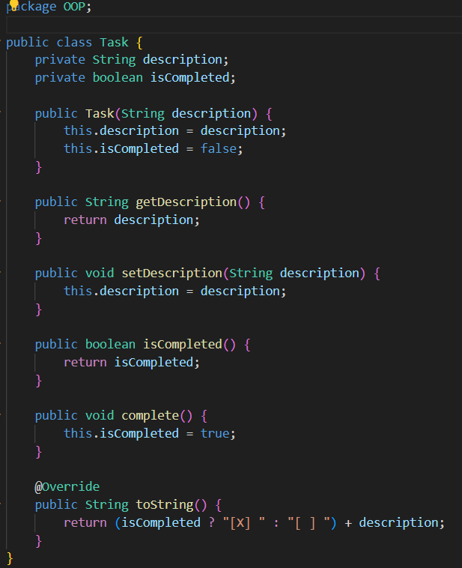

WeeklyToDoListApp Class:  
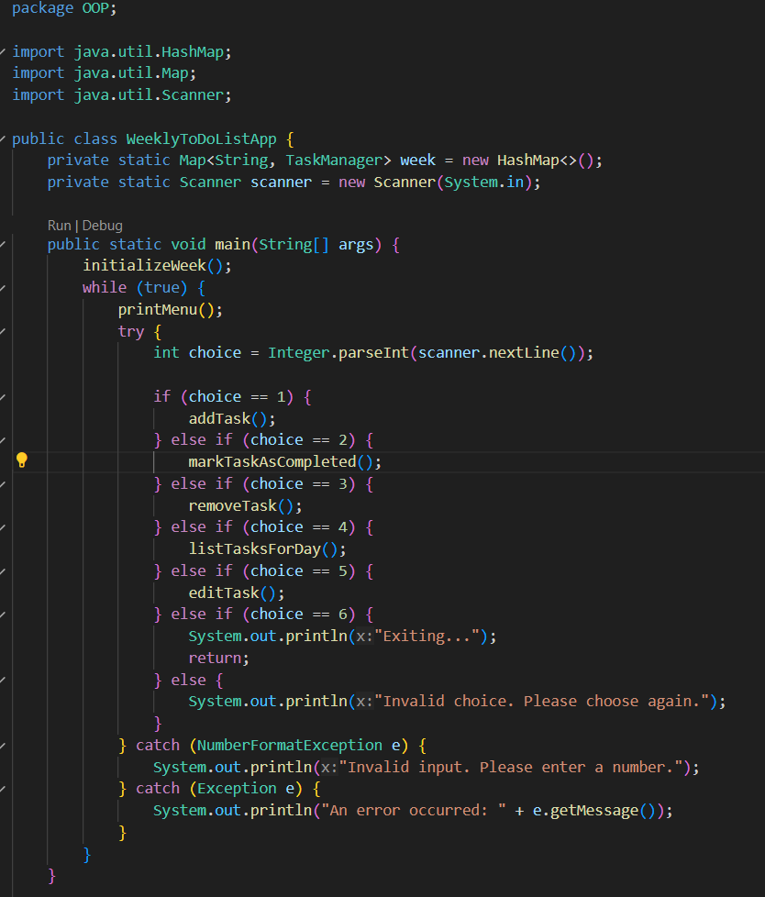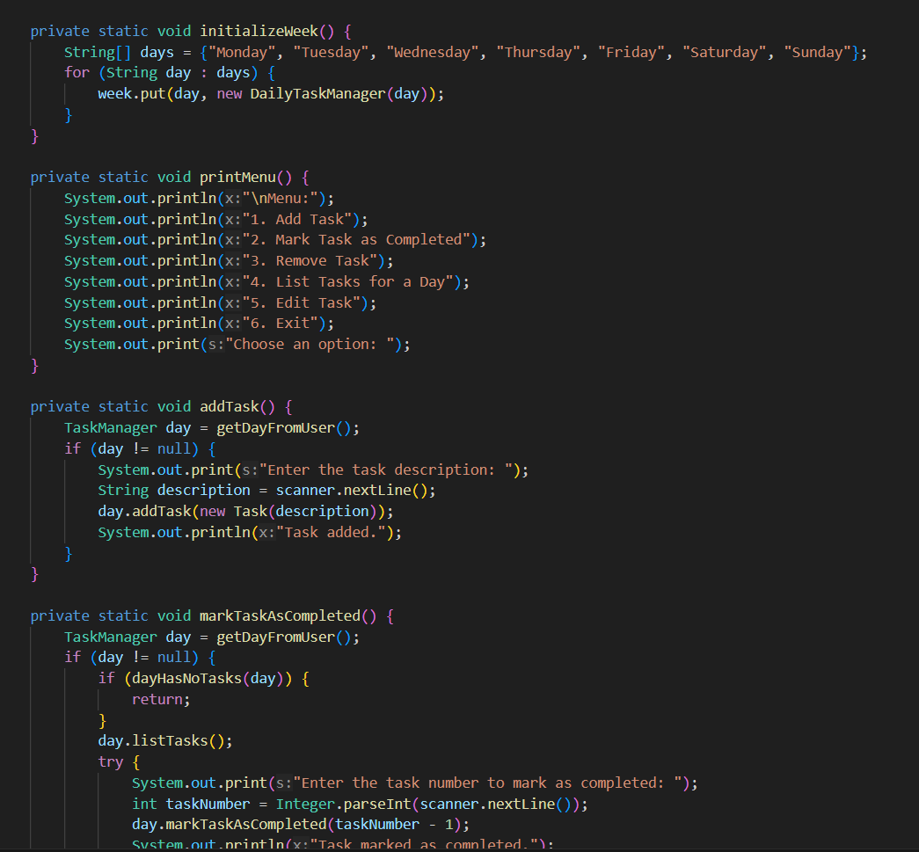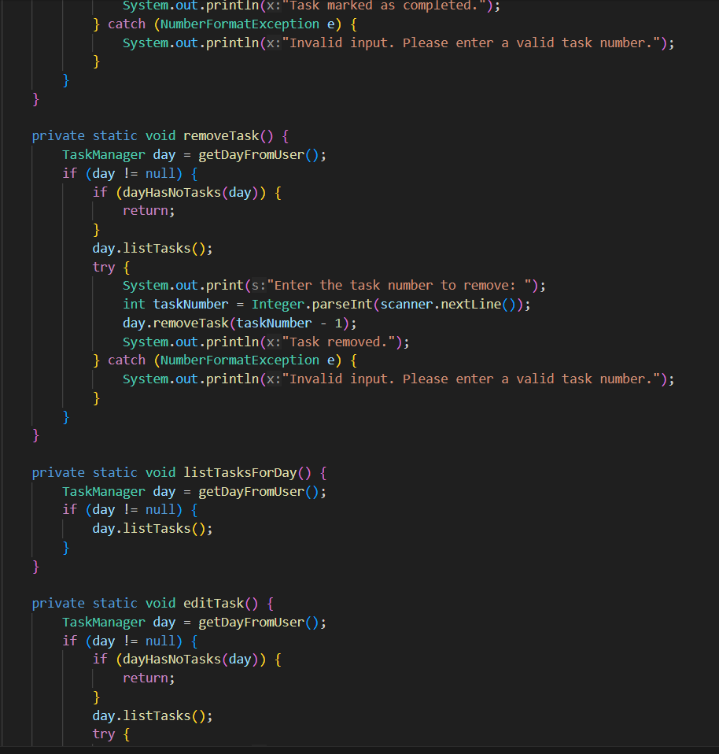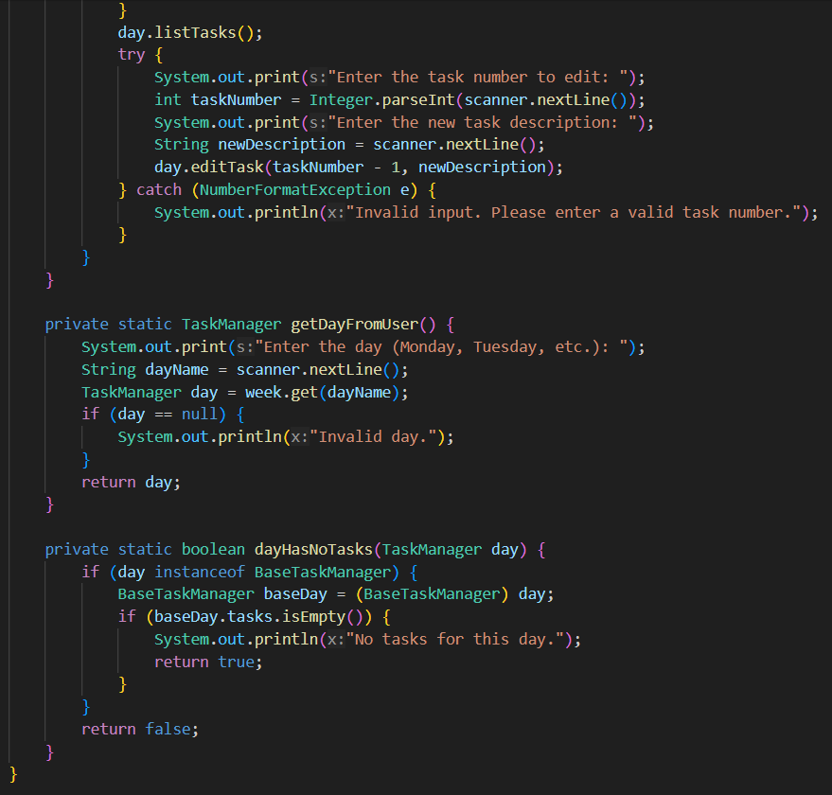

Evidence for working program:

Menu:   
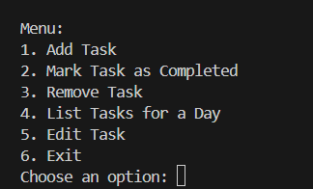

option 1:

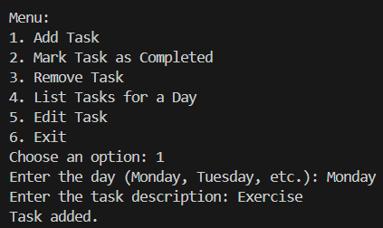

option 2:

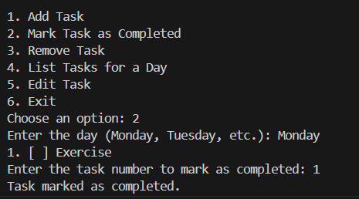

option 3:

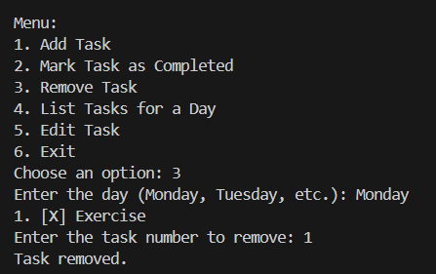

option 4:

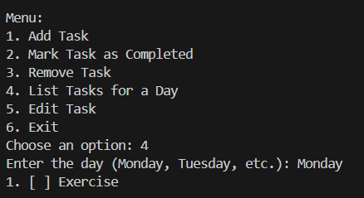

option 5:

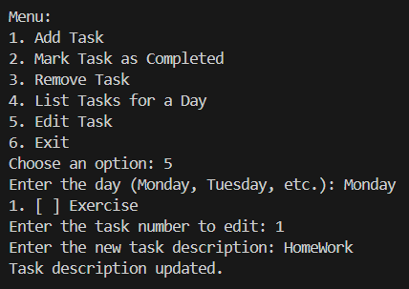

option 6:

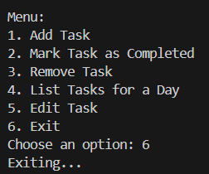

Resources:

* <https://www.geeksforgeeks.org>
* <https://www.w3schools.com/java/default.asp>
* <https://www.freecodecamp.org/news/java-string-to-int-how-to-convert-a-string-to-an-integer/>
* <https://www.studysmarter.co.uk/explanations/computer-science/computer-programming/java-polymorphism/#:~:text=Polymorphism%20in%20Java%20is%20achieved%20through%20the%20two%20main%20mechanisms,as%20in%20the%20parent%20class>)

Poster:

